Using the LiveCloud Function

The LiveCloud function is used in an application to integrate a third-party service with Vizru.
- To create a LiveCloud application, go to Settings > Cloud Services > Create Function.

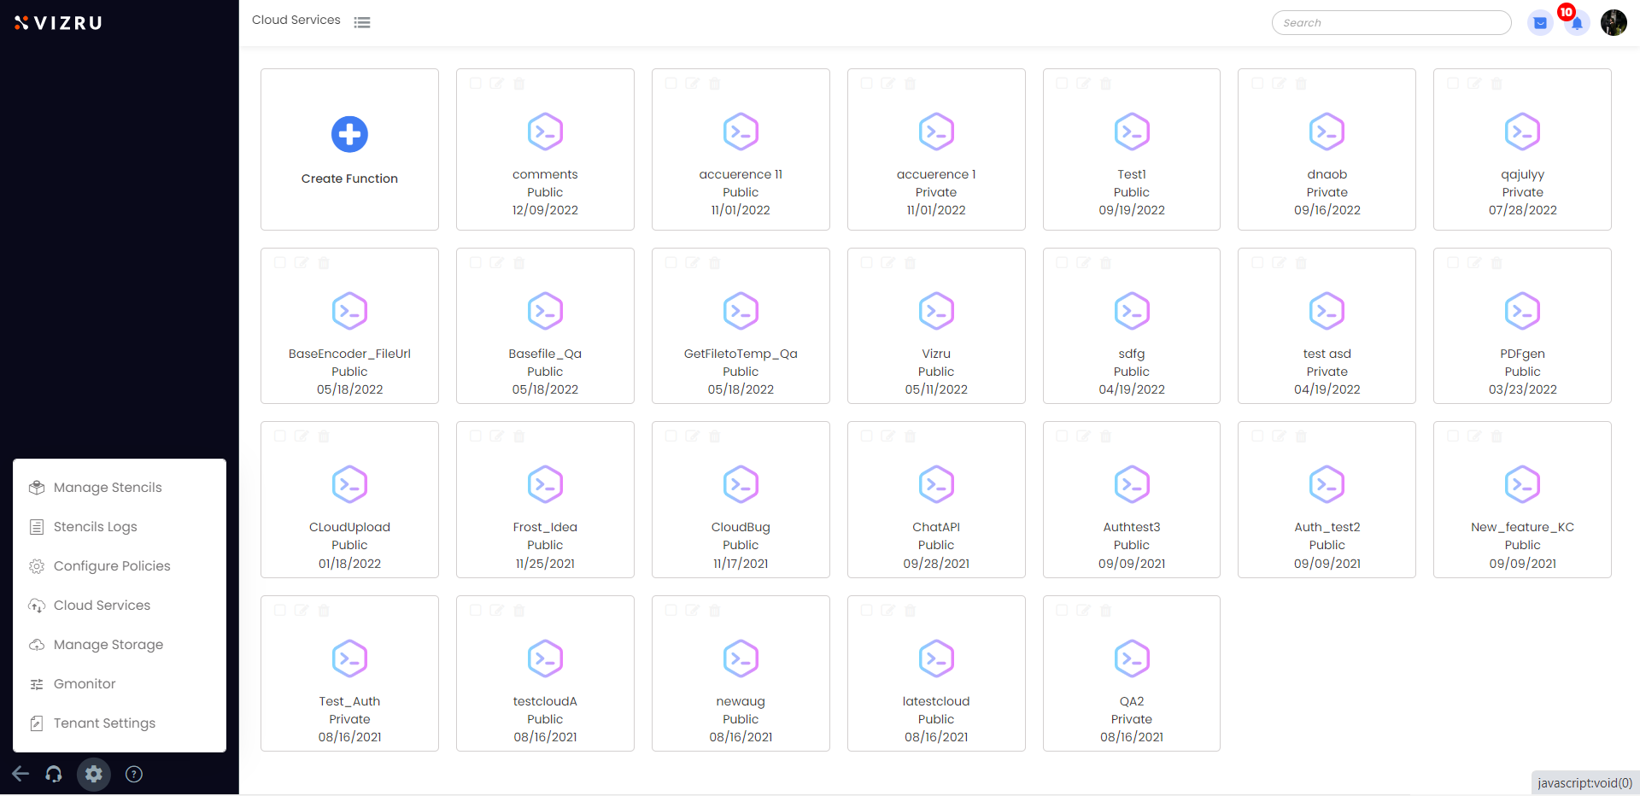

- Enter LiveCloud Application Name, choose an icon, and select Application Type as Public or Private.

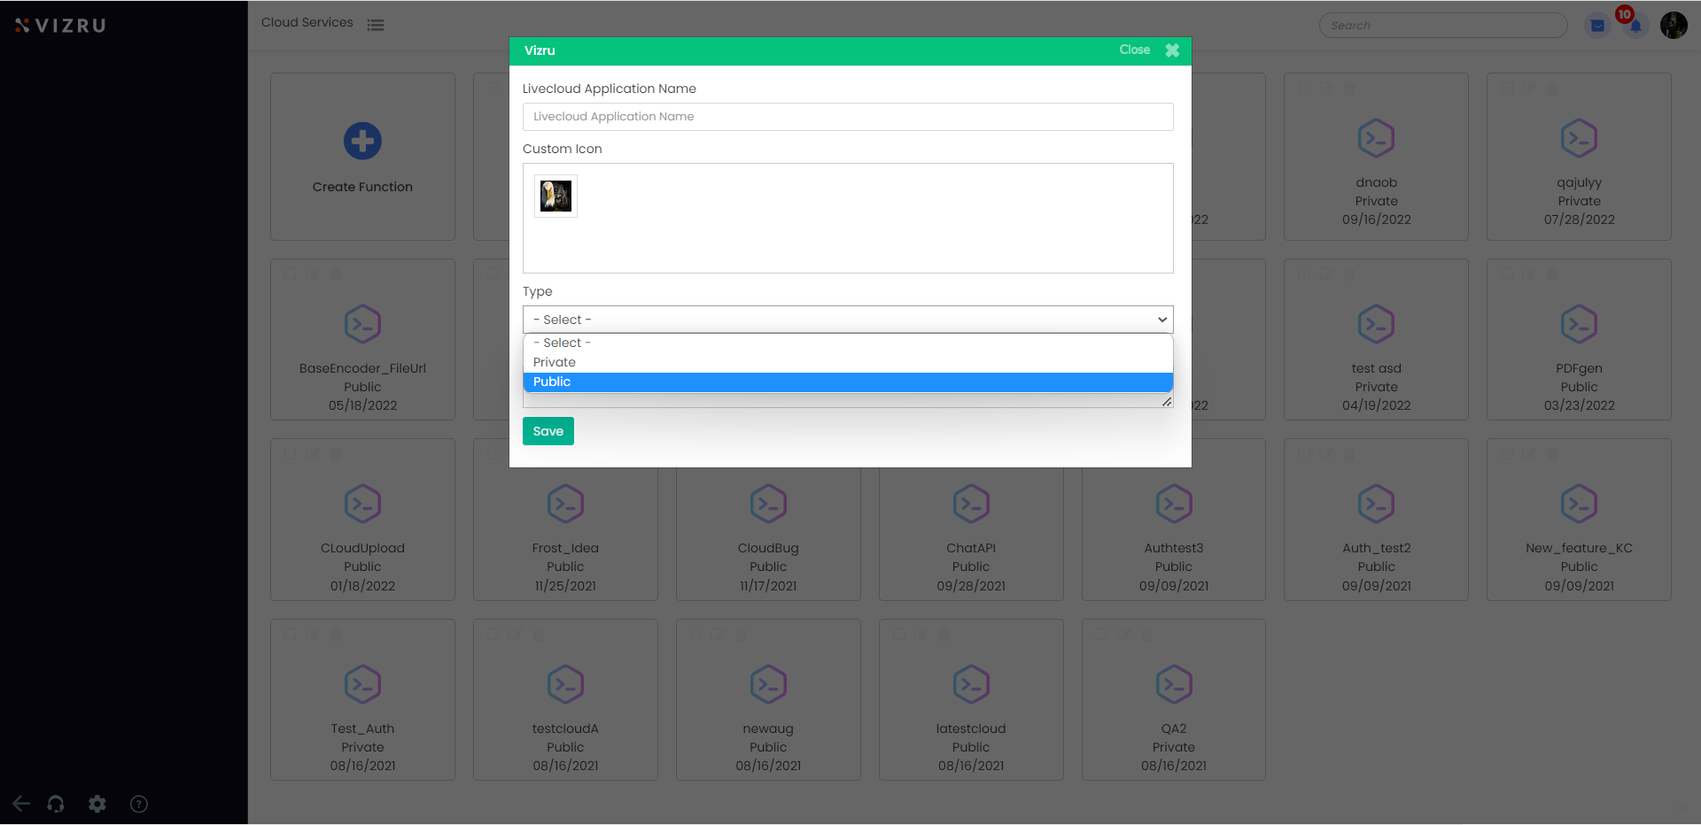
- Save the application.
- To create LiveCloud functions within the application, open the application you just created and hover your mouse over the + icon on the bottom of the page. You find two icons: Create Auth Function and Create General Function.
The Auth function is used to enable authentication, which is necessary to access certain external services. The General function is used to access the external services.

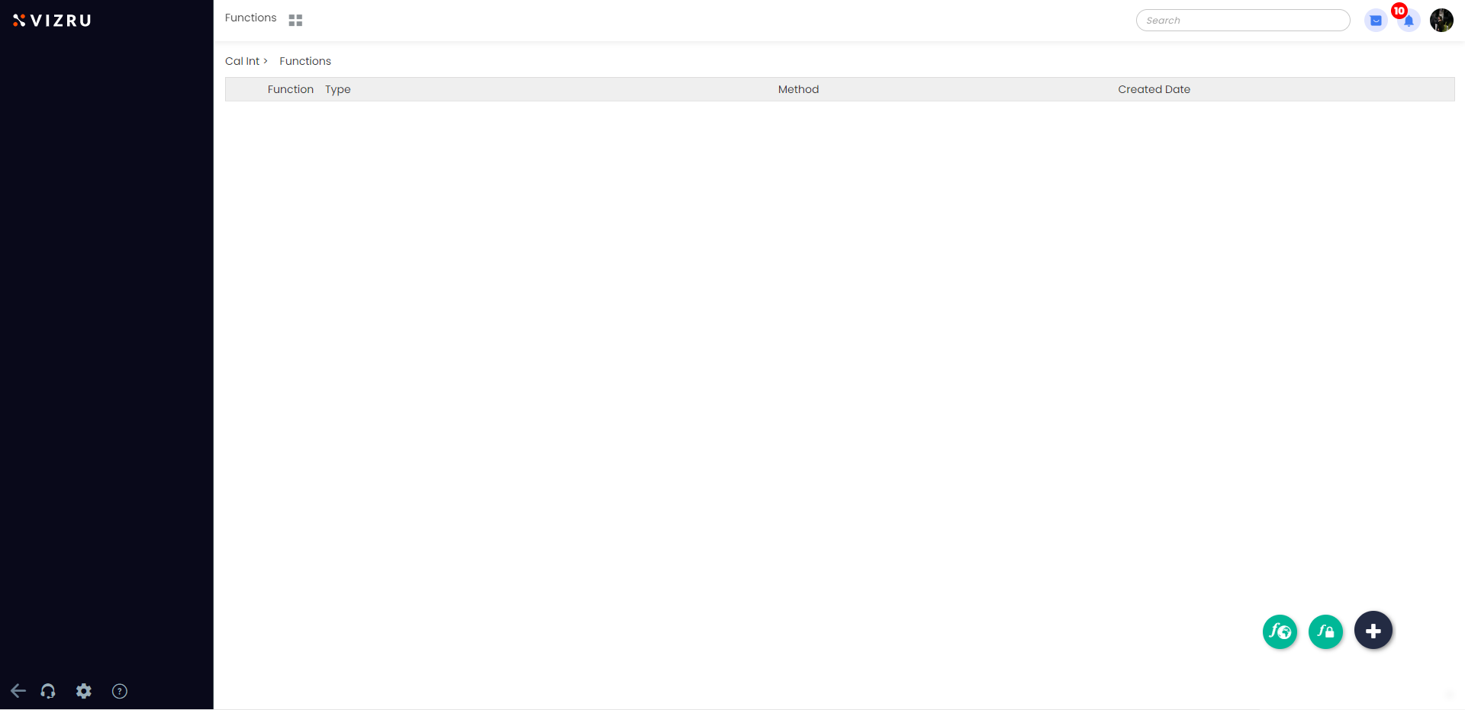

- Click Create Auth Function. The following page is displayed.

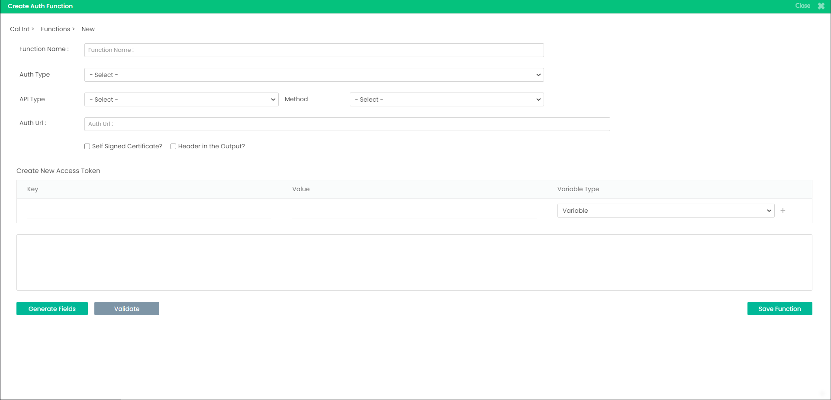
- Enter the Function name.
- Choose Auth Type as OAuth 1.0 or OAuth 2.0 depending on the external service and the protocol that it follows.
- Choose API Type and Method.
Vizru supports REST and SOAP API types. Vsync is used to perform file and SQL operations in legacy systems. Vizru Basic API is used to access web services within Vizru.
- Enter Auth URL as the URL to get the token in return when authentication is completed successfully.
- Pass the expected parameters in the fields “Key” and “Value”, and select the required Variable Type from the dropdown list.

You can choose the following Variable Types.
Fixed : the function takes the parameters as entered
Variable : the parameters can be modified using workflow
HTTP-Header : to send meta-data as HTTP header for some APIs
JSON : to pass a cluster of meta-data in JSON format
URL parameter : to set the URL segment as dynamic and manage using workflow
Enter the parameter in the field “Key” and give the value in the field “Value”.
Secret : to pass confidential data such as passwords in xxxxx format

If the Auth Type is chosen as OAuth 2.0, enter Client ID, Client Secret, Access Token URL, and Scope and click Generate Fields. You now get the access token to make the next request.
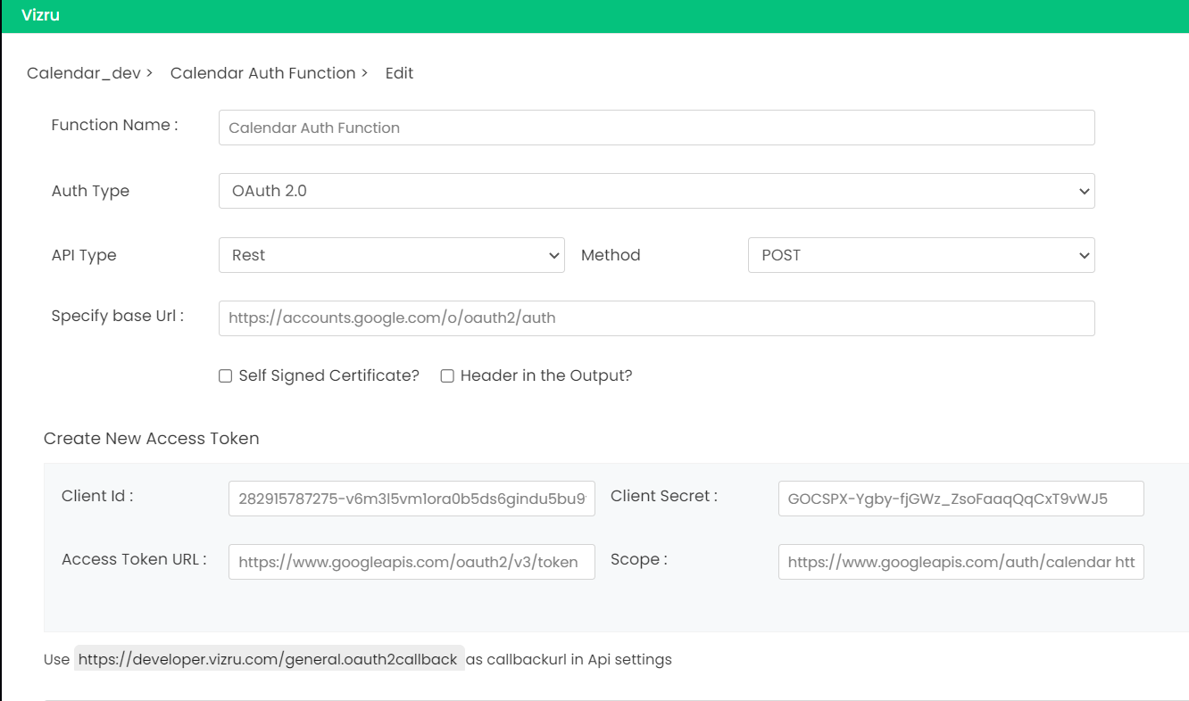

Next, to access the external service, create a General function.
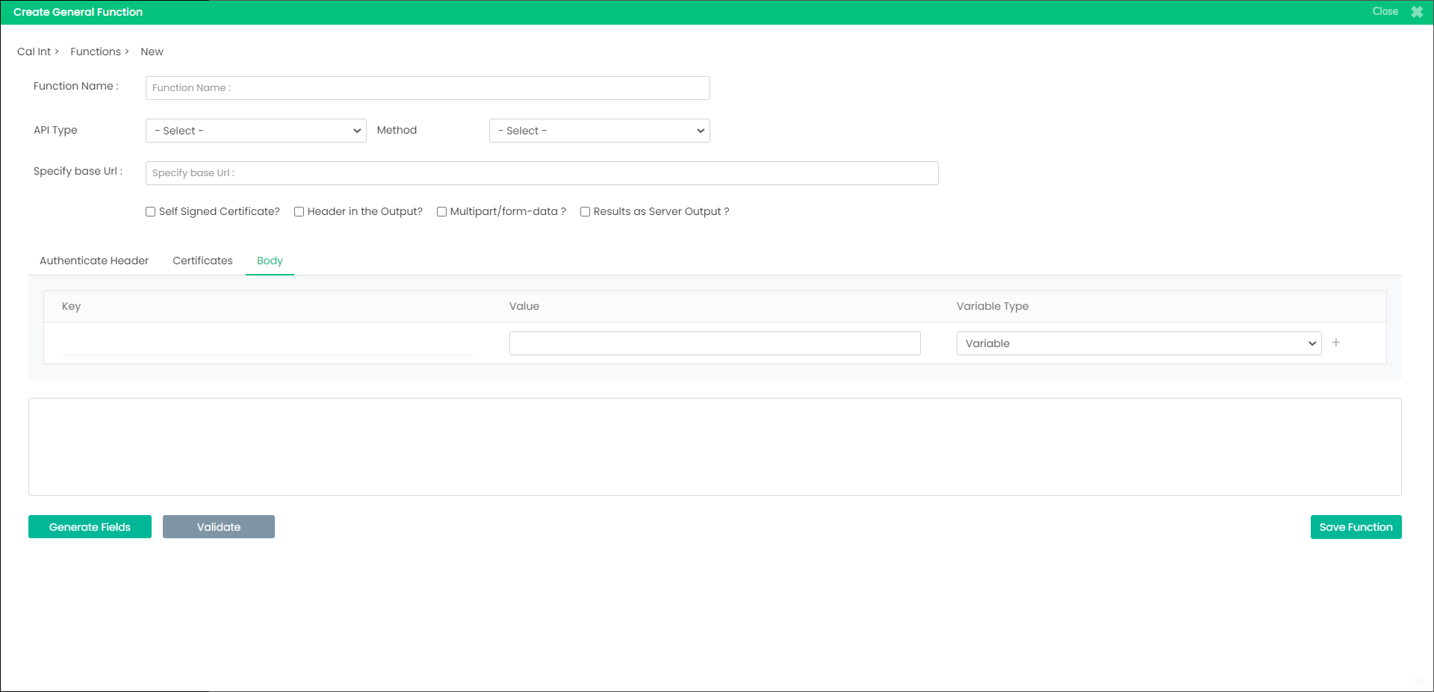
- Enter Function name, choose API Type and Method, and enter base URL to call the external API of the cloud service.
- Select the checkbox for Self Signed Certificate if the third-party integration involves public and private keys for data encryption and decryption.
- Select the checkbox for Header in the Output if you need server HTTP response status codes.
- Select the checkbox for Multipart/form-data if file upload is involved.
- Select the checkbox for Results as Server Output to pass the response exactly same as the server output.

- Click the tab Authenticate Header to connect the Auth function to the General function.
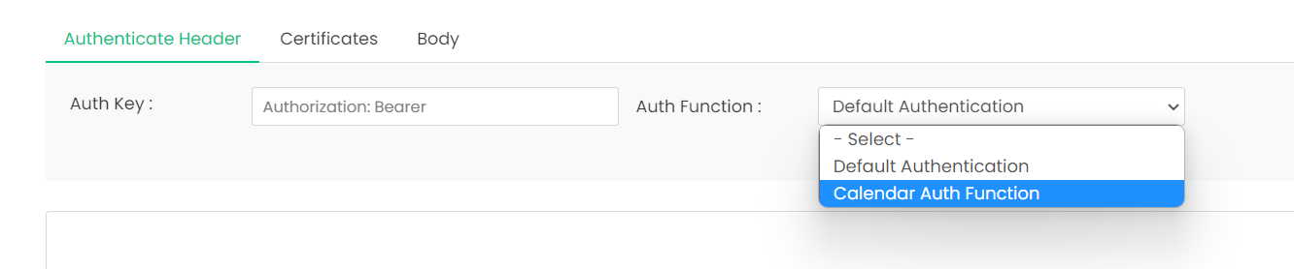
- Select the Auth function you built from the dropdown list.
- Click the tab Certificates to add private keys and certificates.
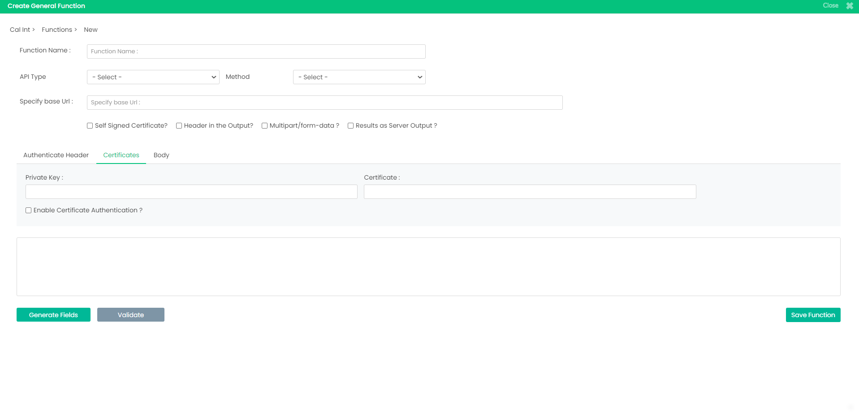
- Click the tab Body to pass the expected parameters to the cloud function. Specify the parameters in the fields “Key” and “Value”, and select the required Variable Type from the dropdown list. The different variable types are explained above. In addition, you can choose the following variable types.
RowData : to pass the input variables as JSON
File : to pass input data as file
Query String : to pass the input variables as URL query string or segment

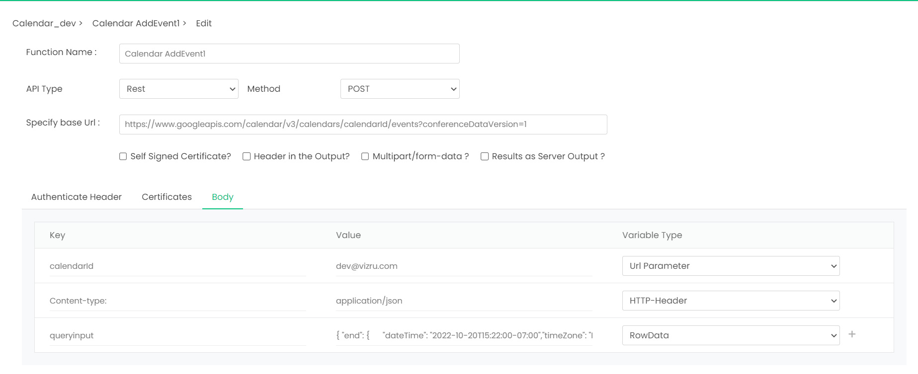

- Your cloud function is built. Add the cloud function to the workflow and map the required parameters in Connection Mapping to integrate the service with your application.

